Unit 4 - Lesson 2 - Establish the PIR
Lesson 2 of 6

Lesson Objectives
In this lesson we aim to:
Understand PIR's

Project information requirements (PIR)
⧉ Audio placeholder (00:09) — no local audio matched this placeholder
PIR is a set of high-level information requirements needed to answer or inform objectives defined by the Appointing Party.
Key decisions such as whether to proceed to the next work stage or not will be made based upon the answers provided.
A key decision point takes place when the appointing party makes a decision based on information provided by the delivery team.
Key decision points define the information delivery milestones and also the information exchanges that take place, typically aligning with the project stages.
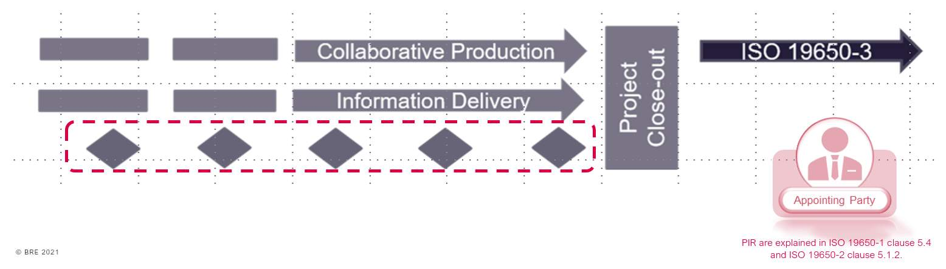
The PIR’s should consider the following:
The project scope & plan of work

Information Purpose
The purpose which the Appointing Party shall use the information, and the reasons why that information is required. Typical purposes include:
Decision making
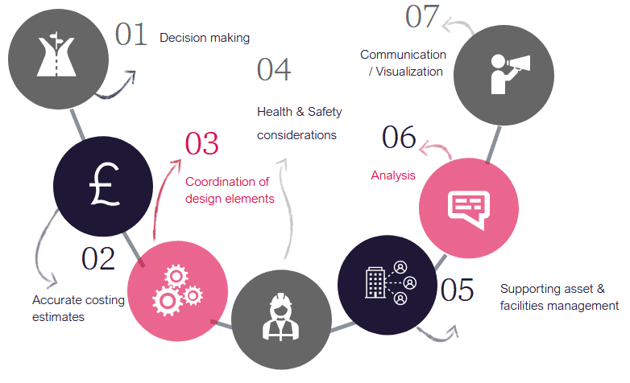
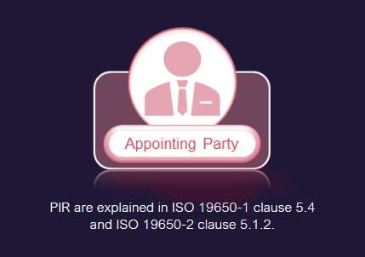

PIR Questions
The questions needed in order for the appointing party to make informed decisions.
Shown here are some typical examples of questions relating to typical project stages in order to satisfy a decision to move to the next stage.
Stage 3 - Does the design meet the federation strategy?
Does the asset comply with relevant regulations?
Does the design information comply with information security management plans?
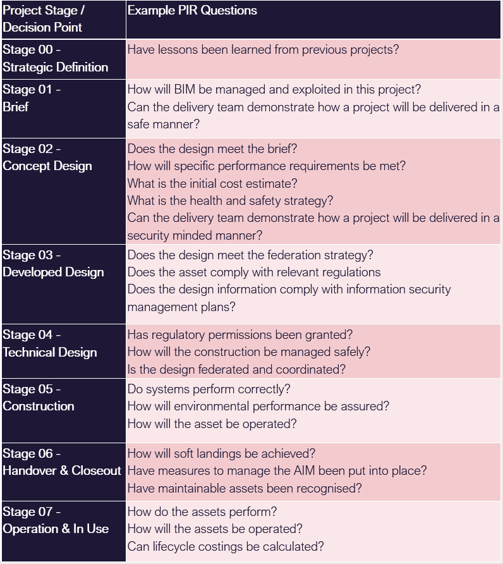

Lesson Summary
Lesson complete! You are now able to:
Understand PIR's
[CONTINUE]

